W-2: Select Online Delivery

What you need to know:
UAMS employees may choose to access their annual federal W-2 tax statements either online through UAMS Employee Self-Service or by mail. By default, you will receive your UAMS by mail unless you complete the steps highlighted below for online access.
- UAMS Employee Self Service use your UAMS network ID and password.
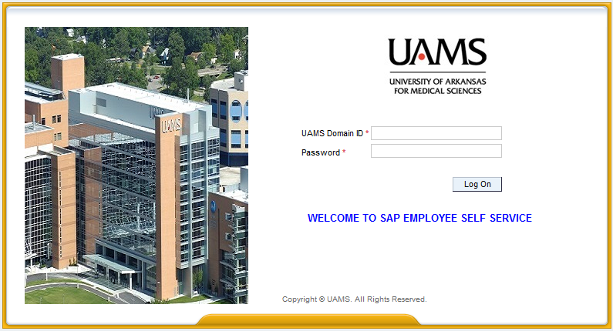
- Click on the “Employee Self Service” tab.
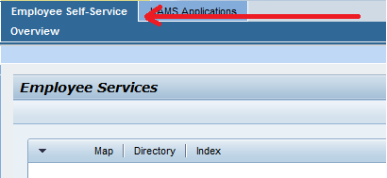
- Choose the “Payments” option.

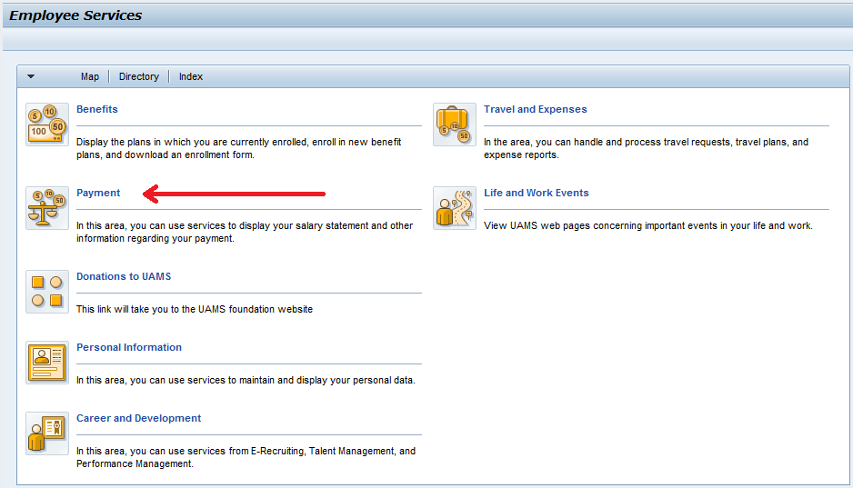

- Click “Election for Online W-2”

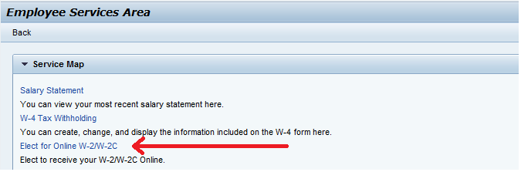

- Under the Election for Online W-2/W-2c header click on the “New Election” option and choose “Elect for Univ of Ark for Med Sciences”.

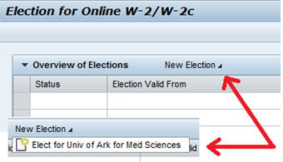
If you do not have the "New Election" option, click the box to the left of the "Election Period Open" for 2014.
- The “Election period open” row will be highlighted and additional information will display for review.
a. Name
b. Social Security Number (will display asterisks “*********”)
c. Election validity dates: The years your election choice will remain valid. The 12/31/9999 date represents your current election will continue until a change is made.
d. Tax Company: UAMS
e. Election period dates: The open election period for employees to choose online Form W-2
f. Additional Information: Used to provide important Form W-2 information

- On the Election Details header click “Receive W-2 Online”.
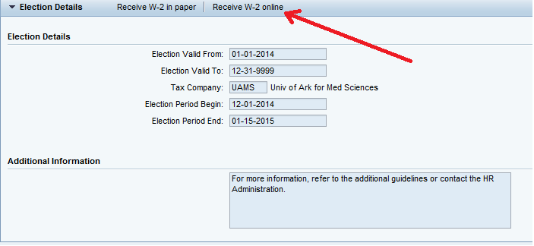
- A confirmation box will pop up to confirm your election to receive an electronic Form W-2 online through Employee Self Service. To confirm that you wish to receive your Form W-2 electronically click “OK”.

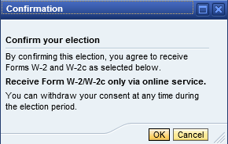

- You will receive the message “Data saved successfully” in the upper left corner of the election screen.
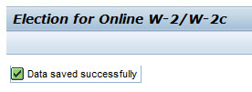
- Click the SAP “Back” button (top right of screen) to return to the Employee Services menu.
You have completed your election to receive your Form W-2 online through Employee Self Service
*** Should you choose to change your election to receive a paper W-2 please follow the same steps above but choose option “Receive W-2 in paper” on step 7. ***

