Menu Navigation Bar
When you sign in, you see the home screen. This menu navigation bar appears across the top of the screen. Here is an overview of each item:
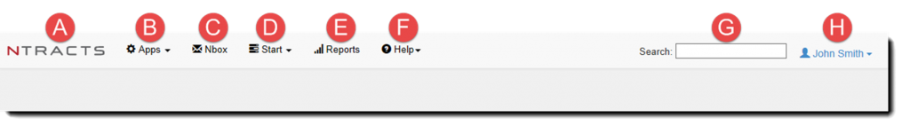
When you click on the Ntracts logo, the entire site will refresh. Any changes you have made will be included in the refresh.
Apps contain:
- Contracts app to create, manage, and view contract records
- Address Book app to capture contact information for people and organizations inside your business as well as external organizations with which you might have a contract with
- Workflow Scheduler app is used in conjunction with Ntracts Support to configure and monitor workflows

Note: The Apps menu appears on your screen only if your user account has permission to access it. Contact your internal system administrator if you think you need access to the Apps menu.
The Nbox is the secure communications center of Ntracts where you can see all of the notifications and action items that are relevant to you.
From the Start menu, Workflows are organized by groups such as Contract where you can initiate a new contract record submission.
If your user account has permissions to initiate workflows, they will appear in this menu.

Note: The Start menu and the workflows only appear on your screen if your user account has permission to access them. Contact your internal system administrator if you think you need access to the Start menu or if you do not see a specific workflow that you need.
From the Reports menu, reports can be executed, scheduled and created based on your permissions.
From the Help menu, you can access user documentation as well as the Support Center, where you can submit and track a support ticket, read release notes, search FAQs, access quick reference guides, and view tutorial videos.
You can use the Search field on the toolbar to search for:
- Contract Records
- Address Book Entries
- Workflows

Enter information you have about an individual, organization, or contract, such as partial last name or an organization name, into the search box.
From the User menu, you can change your password or sign out of the Ntracts application.

