Setting up your Nbox
- After signing into Ntracts, click Nbox on the menu bar.
- The Add an Nbox Tab window appears. The Email Address has been auto-populated. Type your name in the Name field as you wish it to appear on the tab.
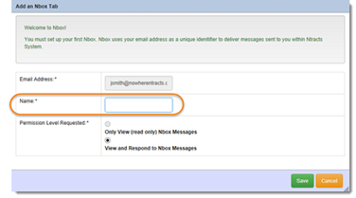
The Permission Level Requested is preselected to View and Respond to Nbox Messages.
- Click Save.
- Click Nbox on the menu bar.
- Click the Refresh List button.
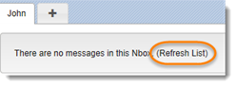
Your Nbox is now set up. Any messages already delivered will be displayed.

