Site Search
You can use the Search field on the toolbar to search for:
            - Contract Records
            - Address Book Entries
            - Workflows
Enter information you have about an individual, organization, or contract, such as partial last name or an organization name, into the search field.
To complete a site search, follow the steps below:
- Enter the first few characters of your search term or phrase in the Search field.
- Once your search term or phrase is recognized, a window will appear below the Search field with any results.
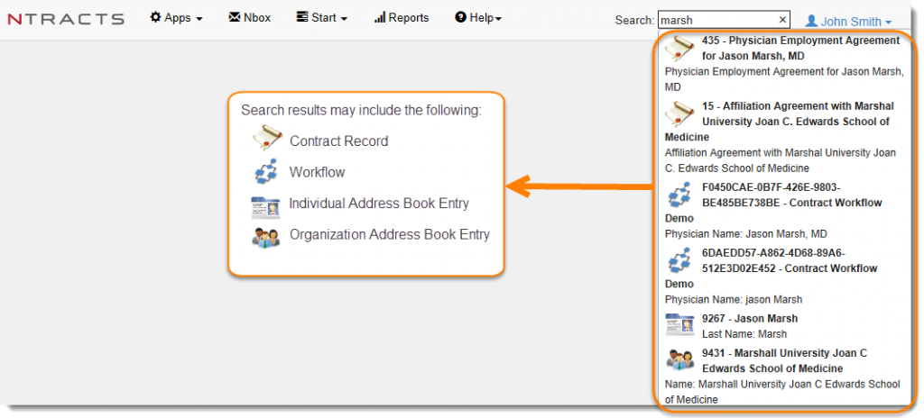
If there are no matches to your search term or phrase, you will see “No Results” in red next to the Search field.
To delete your search term or phrase and start over, click on the X in the Search field.

