Workflow Approval
At A Glance
The Approval Workflow starts with the Contract Initiator creating a new contract record through the “New Contract Workflow (v2.2) in Ntracts. Once the new contract record is submitted, the Contracts Office receives it and puts through to compliance and legal. After all edits/reviews have been made, the contract record will be sent to the Department and Division for their approval. The approvers will receive an email notifying them that they have actions in their Ntracts Nbox. Once the approver signs into Ntracts and locates the action message, they are able to review the contract record and the documents associated with it. Below is the action message where the approval process takes place.
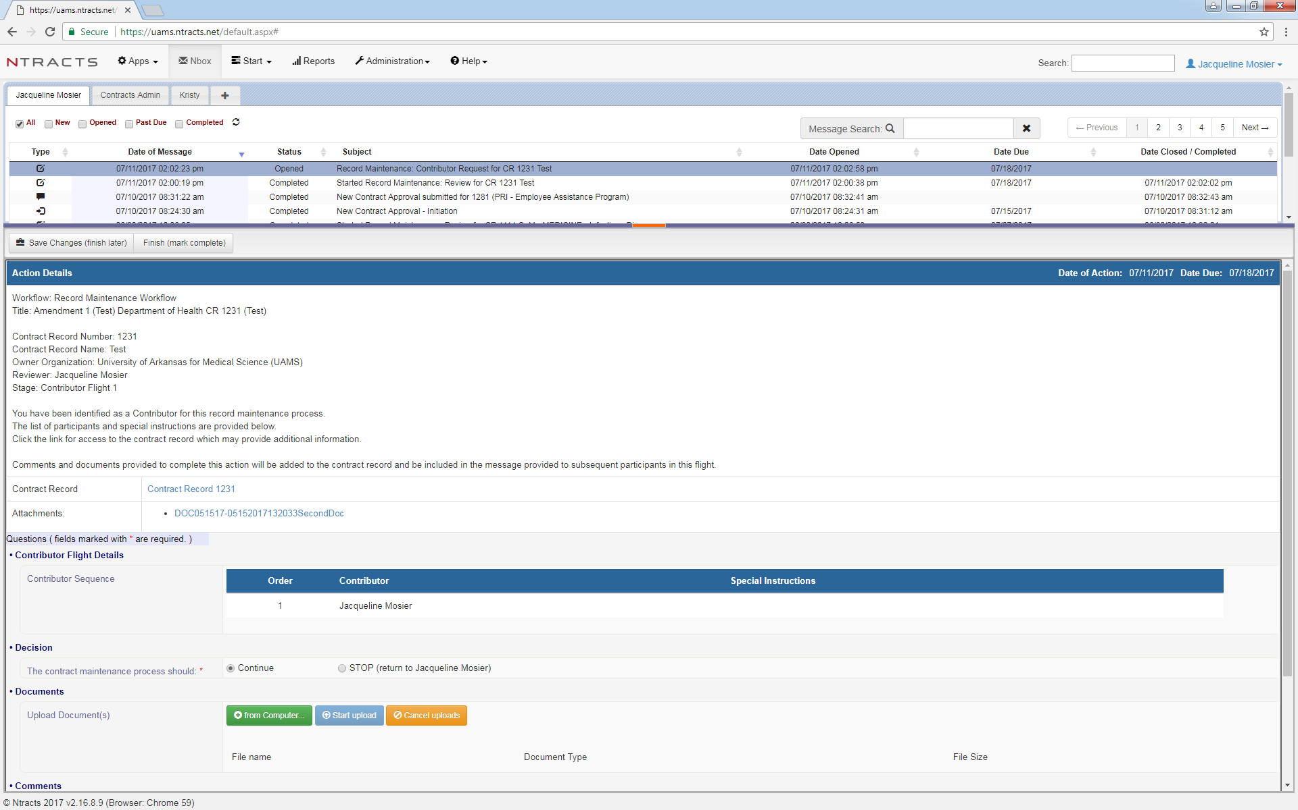
Approval Action Message:
- Contract Record Number(searchable)
- Contract Name: Department/Division Name (searchable)
- Contract Description: Description of the Contract (searchable)
- Owner Organization: University of Arkansas for Medical Sciences
- Reviewer’s Name
- Stage (Flight = Workflow Type)
- Contract Record Link will take you to the full Contract Record
- Attachments are available from the Nbox in order to stay in the Nbox
- Special Instructions for the Approver would appear in this section
- Decision: Continue (Approver) or STOP (returns to Contract Office)
- Documents: Upload any missing or necessary documents related to the contract
- Comments: Leave a comment if something needs to be addressed, noted, or etc., which will be attached to the contract record
- Finish (mark complete) or Save Changes (finish later)

