[](http://www.ntracts.com/) 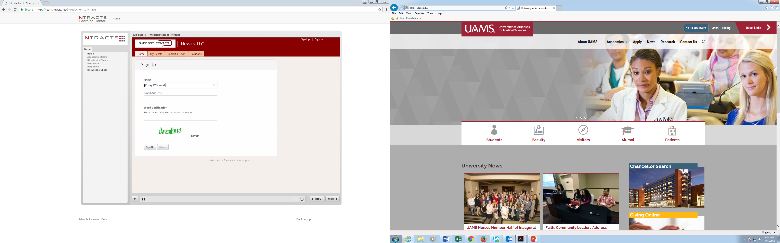

**Deleting Cache/Cookies**

If you are not able to sign into Ntracts, you will need to delete your cache (instructions below).

**Chrome**

1.    Select the following: Browsing history. Download history. Cookies and other site and plug-in data. Cached images and files. ...

2.    Click Clear browsing data.

3.    Exit/quit all browser windows and re-open the browser.

**Firefox**

1.    From the History menu, select Clear Recent History.

2.    If the menu bar is hidden, press Alt to make it visible.

3.    From the Time range to clear: drop-down menu, select the desired range; to clear your entire cache, select “Everything”

4.    Next to "Details", click the down arrow to choose which elements of the history to clear; to clear your entire cache, select all items.

5.    Click Clear Now.

6.    Exit/quit all browser windows and re-open the browser.

**Internet Explorer**

1.    From the History menu, select Clear Recent History.

2.    If the menu bar is hidden, press Alt to make it visible.

3.    From the Time range to clear: drop-down menu, select the desired range; to clear your entire cache, select “Everything”

4.    Next to "Details", click the down arrow to choose which elements of the history to clear; to clear your entire cache, select all items.

5.    Click Clear Now.

6.    Exit/quit all browser windows and re-open the browser.

**Opera (for MAC Users)**

1. Opera stores visited pages both in memory and on disk, so they will be available after a restart. To change the cache settings, go to Settings > Preferences > Advanced > History and choose from the following options in the Disk Cache section:

|  |  |  |
| --- | --- | --- |
| Action | How to do it | Notes |
| Empty the cache | Click Empty Now | This deletes all cached content from the disk |

Once you have done that, type <https://uams.ntracts.net>, click on adfs.uams.edu and sign in how you do to get into any of the UAMS accounts (Email, Employee Self Service, etc.).

